Implementation of DBMS, Exercise Sheet 10, KM., WS 2024 / 2025
1a. Hash Table with Minimum and Maximum Blocks
Suppose we have a file of 2,500,000 records that we want to hash into a table with 2,500 buckets. Each block can store 200 records, and we wish to maximize block utilization while ensuring that no two buckets share a block. Empty buckets do not consume a block. What is the minimum and maximum number of blocks required to store this hash table?
Soln: min = 12500 blocks, max = 14987 blocks

1b. Hash Table with Variable Records
Suppose we have a file of 750,000 records that needs to be hashed into a table with 1,500 buckets. Each block can hold 150 records. We wish to minimize the number of blocks used while ensuring that no two buckets share a block. Empty buckets do not consume a block. Determine the minimum and maximum number of blocks required.
Solutn: min = 6000 blocks, max = 6490 blocks

2a. Extensible Hashing Simulation
Suppose keys are hashed to five-bit sequences, and blocks can hold four records. If we start with a hash table with two empty blocks (corresponding to 0 and 1), show how the hash table evolves when we insert records with the following hash values:
00000, 00001, ..., 11111, and the method of hashing is extensible hashing.

2b. Simulating Hash Table Growth
Suppose keys are hashed to three-bit sequences, and each block can hold two records. Begin with a hash table consisting of two empty blocks (corresponding to 0 and 1). Trace the changes in the hash table as you insert keys with the following hash values:
000, 001, ..., 111, using extensible hashing. Show the final state of the hash table.

3a. Recursive Overflow Probability
In an extensible hash table, blocks can hold n records before splitting. If a split occurs after n+2 records are added, what is the probability that an overflow will have to be handled recursively, i.e., all records are placed into the same one of the two blocks created during the split?

3b. Recursive Overflow Probability with Additional Records
Consider an extensible hash table with blocks capable of holding n records. If a split occurs after n+4 records are added, calculate the probability that the overflow requires recursive handling, i.e., all n+4 records are assigned to the same one of the two newly created blocks.

Exam.p.
"A linear hash table with a capacity threshold of 80%. Suppose that keys are hashed to four-bit
blocks can hold two records.
What is the minimum number of records we have to insert to get a hash table with 5 buckets?
Provide an example of a hash table with exactly 4 buckets and 2 overflow blocks. Draw the n
with their hash values."

two more examples

Example 1:
A linear hash table has a capacity threshold of 75%. Assume that keys are hashed to five-bit values and that each bucket can store three records.
- What is the minimum number of records that must be inserted to ensure the hash table expands to 6 buckets?
- Provide an example of a hash table with exactly 5 buckets and 3 overflow blocks. Draw the records along with their hash values.

Example 2:
A dynamic hash table follows a capacity threshold of 85%. Suppose keys are hashed to six-bit values and each bucket can hold four records.
- What is the minimum number of records needed to expand the hash table to 8 buckets?
- Construct an example of a hash table with exactly 6 buckets and 4 overflow blocks. Illustrate the records and their hash values.

Question 3a:
In an extensible hash table with 2 records per block, what is the probability that an overflow will have to be handled recursively, i.e., all members of the block will go into the same one of the two blocks created in the split? Assume that the hash function distributes keys uniformly.

Question 3b:
In an extensible hash table with 3 records per block, what is the probability that an overflow will have to be handled recursively, i.e., all members of the block will go into the same one of the two blocks created in the split? Assume that the hash function distributes keys uniformly.

Question 3c:
In an extensible hash table with 4 records per block, what is the probability that an overflow will have to be handled recursively, i.e., all members of the block will go into the same one of the two blocks created in the split? Assume that the hash function distributes keys uniformly.

How to Solve These Questions:
Step 1: Understand the Problem
- For a block with nn records, an overflow occurs when the block is full.
- When the block is split, each record has a 50% chance of going to either of the two new buckets (assuming a uniform hash function).
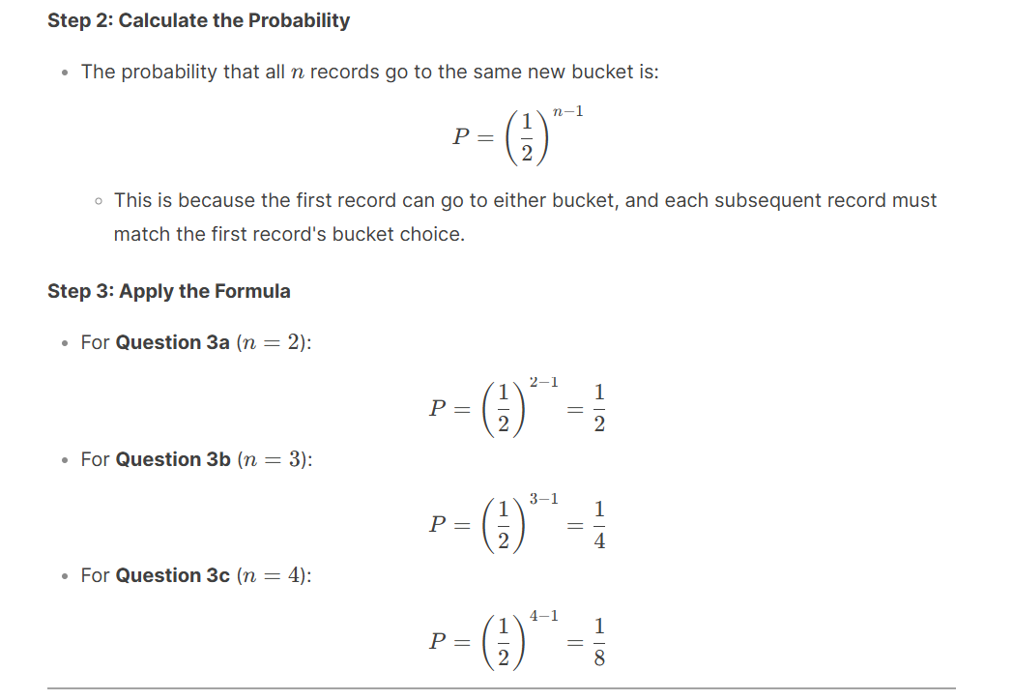
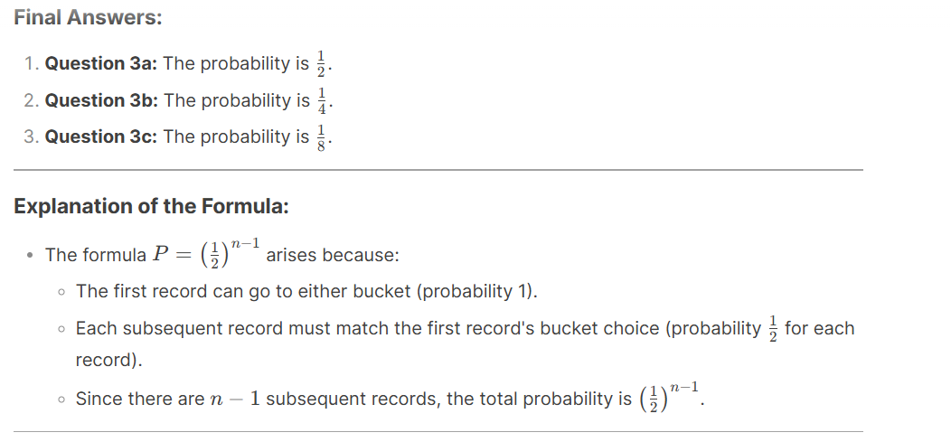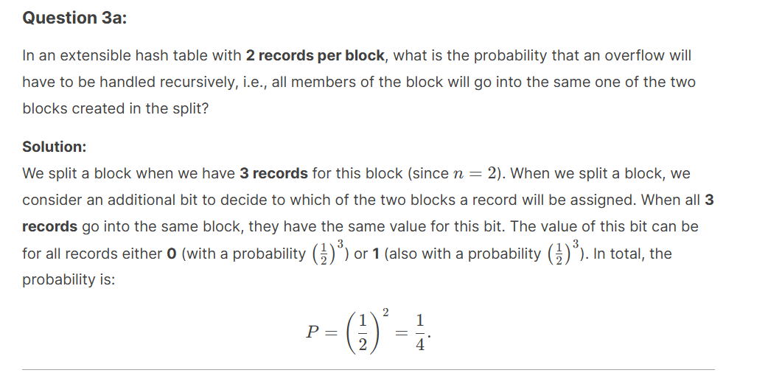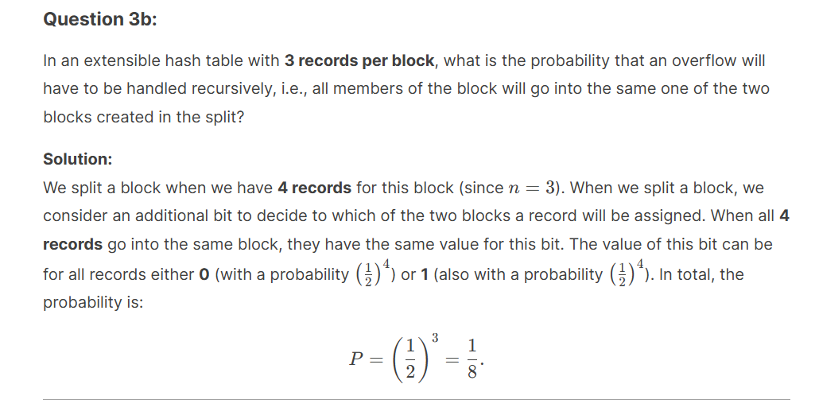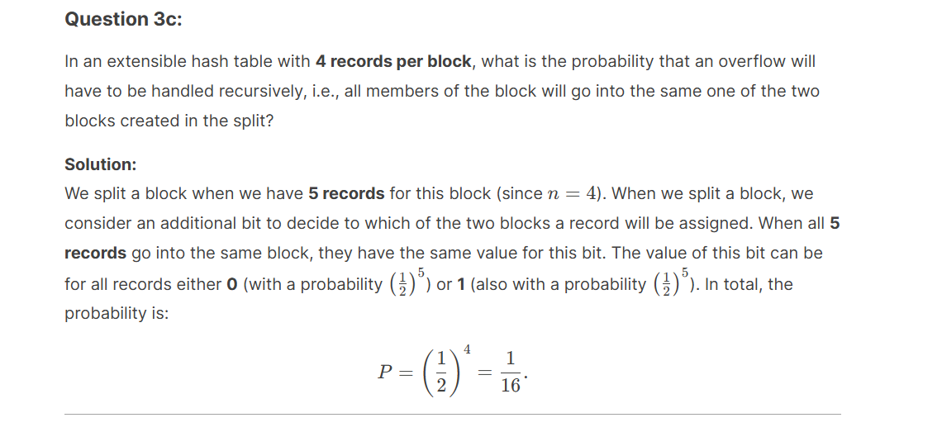
1a) Suppose we have a file of 2,000,000 records that we want to hash into a table with 2,000 buckets. Each bucket can hold 50 records, and we wish to minimize the blocks used while not allowing two buckets to share a block. Empty buckets do not consume a block. What is the minimum and maximum number of blocks needed?
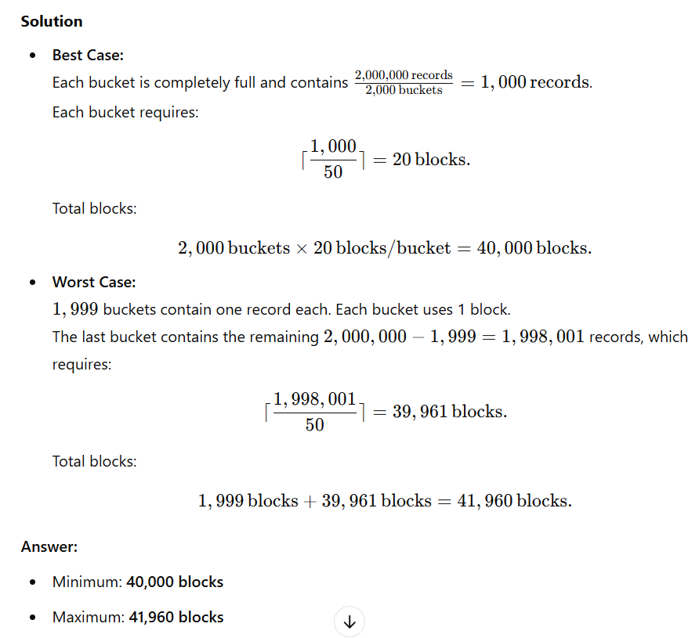
Question 3a:
In an extensible hash table with n records per block, what is the probability that an overflow will occur such that all n+1 records have hash values that assign them to the same block after splitting? Assume the hash function produces uniform random values.
Explanation:
When a block overflows in an extensible hash table, it splits into two new blocks, and an additional bit of the hash value determines which block each record goes into. The probability of all n+1 records ending up in the same block is given by (1/2) ^n, as the split evenly assigns records to one of the two blocks with a 50% chance per record. This probability reflects the chance of requiring further recursive splits due to an imbalance.

Question 3b:
Suppose we have an extensible hash table with n records per block, and each record’s hash value is independently distributed. What is the probability that, after a split, all but one of the n+1 records end up in the same block, requiring additional reorganization?

🧩 Question 1a – Uniform vs. Skewed Hash Distribution (Medium)
A hash table is created to store 2 million records using 2 000 buckets.
Each disk block can hold 80 records, and each bucket must occupy whole blocks (buckets cannot share blocks).
Empty buckets do not consume blocks.
Tasks
a) Compute the best-case number of blocks required if the hashing function distributes records perfectly evenly.
b) Compute the worst-case number of blocks required if all but one bucket contain only a single record.
c) Explain in one sentence how load imbalance affects total storage.

🧩 Question 1b – Bucket Utilization and Wasted Space (Advanced)
You are designing a hash file with 500 buckets to store 350 000 records.
Each block holds 50 records.
No two buckets may share a block.
A performance requirement states that the average block utilization must not drop below 70 %.
Tasks
a) In the best case, how many blocks are needed?
b) If hashing is uneven and 50 buckets each contain only 10 records, compute:
- the extra blocks wasted due to under-filled buckets, and
- the resulting overall utilization of all allocated blocks.
c) Suggest one dynamic hashing technique that would minimize this inefficiency and briefly state how it works.

